DOI 10.1007/s10994-013-5425-9

EDITORIAL

Enhancing Support Vector Machines with Fuzzy M-Estimator

Inspired Approaches for Robust Classification

# Min Gyeong Kim 1,† · Jia Yoo 1,† · Jin Hee Yoon1,*

Received: 17 October 2013 / Accepted: 15 November 2013 / Published online: 28 November 2013

© The Author(s) 2013

**Abstract**

Support Vector Machines (SVMs) are widely used for classification due to their strong generalization capabilities, but they remain sensitive to outliers and noise, particularly near decision boundaries. To enhance robustness and better manage boundary uncertainty, we propose a robust extension of the Support Vector Machine (SVM) framework by integrating M-estimator-based loss functions with fuzzy membership values to enhance classification performance in the presence of noise and outliers. We reformulate the SVM in a flexible primal optimization framework that allows for the integration of non-convex loss functions, including Fair, Cauchy, Welsch, and Geman-McClure, are utilized within the fuzzy M-estimators to assign adaptive weights and suppress the influence of noisy or misclassified data. Our method is evaluated on benchmark datasets such as Arrhythmia, Madelon, WBC, and Ionosphere, with artificial noise introduced to assess robustness. Experimental results show that the proposed fuzzy M-estimator SVMs, particularly those using Cauchy and Welsch functions, achieve higher classification accuracy and robustness under noisy conditions compared to traditional L1 and L2-SVMs. This approach offers both theoretical robustness and practical flexibility for real-world noisy data environments.

(To be rewritten after completing the data analysis)

# 

# 

**Keywords** Support Vector Machine · Fuzzy · Robustness · Classification · M-estimator

# 1 Introduction

Support Vector Machines (SVMs) have achieved widespread success due to their ability to construct optimal hyperplanes for classification, even in high-dimensional and small-sample settings. However, traditional SVMs are often vulnerable to noise and outliers because they rely on loss functions—like the L2 loss—that grow quadratically with residuals and therefore

|  |
| --- |
| Editor |

* Min Gyeong Kim

[alsrud8238@gmail.com](mailto:alsrud8238@gmail.com)

Jia Yoo

[jia0220@naver.com](mailto:jia0220@naver.com)

Jin Hee Yoon

[jin9135@sejong.ac.kr](mailto:jin9135@sejong.ac.kr)

1. Department of Mathematics and Statistics, Sejong University, Seoul 05006, South Korea

**†** These two authors contributed equally to this work.

# exaggerate the impact of outliers.

# To address this issue, robust loss functions based on M-estimators have been proposed. These include L1, Fair, Cauchy, Welsch, and Geman-McClure losses, which reduce the effect of extreme residuals through bounded or slowly-growing penalties. These approaches improve stability under noisy conditions, but typically assume that all class boundaries are sharply defined and do not explicitly incorporate the ambiguity or partial membership that often arises in real-world classification problems.

In this study, we propose a novel classification framework that integrates fuzzy set theory into M-estimator-based SVMs. By assigning fuzzy membership values to data points, the model can reflect degrees of class belonging, enabling softer and more adaptive decision boundaries in uncertain or overlapping regions. At the core of our contribution is the fuzzy M-estimator loss function, a unified formulation that combines the robustness of M-estimators with the flexibility of fuzzy membership.

Furthermore, we extend this fuzzy M-estimator SVM model to both binary and multi-class classification settings, employing standard strategies such as One-vs-One, One-vs-Rest, and direct optimization. To evaluate the robustness of the proposed model, we design experiments that introduce and remove outliers from the data, allowing us to examine its behavior under varying levels of contamination. This framework lays a foundation for the development of classifiers that remain reliable in the presence of noise, label ambiguity, and class overlap.

# Key Contributions of This Study:

1. Development of an M-estimator-inspired robust SVM framework that significantly enhances classification accuracy in noisy environments.
2. Comparative evaluation of multiple loss functions (Fair, Cauchy, Welsch, Geman-McClure) to determine the most effective robust loss formulation.
3. Comprehensiveoptimization analysis, comparing metaheuristic algorithms (GA, PSO, ACO, HS) with SMO to identify the best training method.
4. Empirical validation on multiple benchmark datasets for binary classification, including Arrythmia, Madelon, WBC, and Ionosphere, with artificially induced noise.

# The remainder of this paper is structured as follows. The next section provides an in-depth discussion of robust loss functions and optimization strategies. We then describe our experimental setup, dataset characteristics, and evaluation methodology, followed by the results of our comparative analysis. Finally, we conclude with a discussion of key findings, practical implications, and future research directions. Our experimental results demonstrate that integrating M-estimator-based loss functions with advanced optimization techniques significantly improves classification accuracy and stability in noisy environments, providing a practical and effective solution for real-world machine learning applications.

**2 Support Vetor Machines**

Support Vector Machine (SVM) is a powerful supervised learning algorithm widely used for classification and regression tasks. The core idea of SVM is to find the optimal hyperplane that separates data points of different classes with the maximum margin. Given a training dataset ${\{(x_{i},y_{i})\}}_{i=1}^{n}$ where $x_{i}∈R^{d}$ and $y_{i}∈\{-1, 1\}$, SVM aims to identify a hyperplane de-fined by $w^{T}x+b=0$ such that the margin between support vectors is maximized.

**2.1 Hard Margin SVM**

In the ideal case where data is linearly separable, the Hard Margin SVM formulation is used. The optimization problem is defined as:

$$\min_{w,b}{\frac{1}{2}{\left\|w\right\|}^{2}} s.t. y_{i}\left(w^{T}x_{i}+b\right)≥1, ∀i$$

This formulation attempts to find the hyperplane with the largest possible margin that perfect-ly separates the data. However, in practical applications, perfect separability is rare due to noise or overlapping class distributions.

**2.2 Soft Margin**

To handle cases where data is not perfectly separable, Cortes and Vapnik (1995) introduced the Soft Margin SVM. This approach introduces slack variables $ξ_{i}≥0$ to allow for margin violations:

$$\min_{w,b,ξ}{\frac{1}{2}{\left\|w\right\|}^{2}+C\sum_{i=1}^{n}{ξ_{i}}} s.t. y_{i}\left(w^{T}x_{i}+b\right)≥1-ξ_{i}, ξ_{i}≥0$$

Here, C is a regularization parameter that balances the trade-off between maximizing the mar-gin and minimizing the classification error. While Soft Margin SVM provides robustness to small levels of noise, it still treats all data points with equal importance, making it sensitive to outliers and mislabeled data.

**2.3 Introduction of Fuzzy Logic in SVM**

Fuzzy logic provides a mechanism to model uncertainty and partial truth, which can be particularly useful in real-world data that contains noise, outliers, or ambiguities. In the context of SVM, fuzzy logic is introduced by assigning a membership value $m_{i}∈[0, 1]$ to each training sample $x_{i}$, which represents the degree of confidence or importance of the sample.

The modified objective function for fuzzy SVM becomes:

$$\min_{w,b,ξ}{\frac{1}{2}{\left\|w\right\|}^{2}+C\sum_{i=1}^{n}{m_{i}ξ_{i}}} s.t. y_{i}\left(w^{T}x_{i}+b\right)≥1-ξ_{i}, ξ_{i}≥0$$

This formulation allows the model to reduce the influence of uncertain or noisy samples by down-weighting their contribution to the loss. Samples with low membership values (e.g., suspected outliers) will have a reduced impact during training, thereby enhancing the robustness of the model.

Fuzzy SVM has been shown to perform better than traditional SVMs in noisy environments, imbalanced datasets, and applications where certain samples carry varying degrees of re-liability. The assignment of fuzzy membership values can be based on distance measures, density estimation, or more recently, derived from robust statistics such as M-estimators, which are further explored in this study.

**3 Proposed Robust Classification Method using M-Estimators**

**3.1 Limitations of Traditional SVM**

Traditional SVM aims to maximize the margin and minimize classification errors. However,

this structure is fundamentally vulnerable to noise, outliers, and label errors in real-world data. Since all data points are treated equally in traditional SVM, samples with low reliability or extreme values can overly influence the model. In real classification problems, mislabeled samples, outliers, and overlapping boundary cases frequently occur. These instances equally participate in the training, resulting in distorted decision boundaries and unstable test performance.

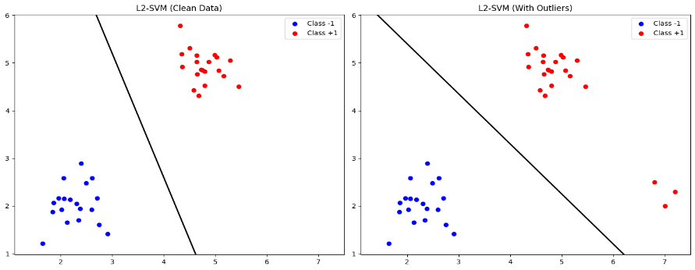

Figure 1 Effect of Outliers on Decision Boundaries

Traditional SVM lacks a mechanism to adaptively weight samples based on their reliability or error characteristics. Therefore, a loss function structure that can differentiate the influence of each sample is essential for improving robustness in practical environments. This highlights the need for an alternative loss function to enhance SVM robustness, which will be introduced in the following section.

**3.2 Robust M-Estimators for SVM**

M-estimation is a statistical technique developed to reduce sensitivity to outliers by modifying the rate of loss growth according to the size of the residual. When applied to the SVM loss function, it enables the model to remain sensitive to small errors while suppressing the influence of large errors.

Traditional SVMs commonly employ the following loss functions:

$$L_{1}\left(ξ_{i}\right)=\left|ξ_{i}\right|$$

$$L_{2}\left(ξ_{i}\right)=\frac{{ξ_{i}}^{2}}{2}$$

These functions increase linearly (L1) or quadratically (L2) as residuals grow, offering no mechanism to limit the influence of outliers, which may severely distort the decision boundary.

To address these limitations, this study applies the following four representative M-estimation loss functions:

$$L_{Fair}\left(ξ_{i}\right)=c^{2}\left[\frac{\left|ξ_{i}\right|}{c}-log\left(1+\frac{\left|ξ_{i}\right|}{c}\right)\right]$$

$$L_{Cauchy}\left(ξ_{i}\right)=\frac{c^{2}}{2}log⁡\left(1+{\left(\frac{ξ_{i}}{c}\right)}^{2}\right)$$

$$L_{Welsch}\left(ξ_{i}\right)=\frac{c^{2}}{2}\left[1-exp\left(-{\left(ξ_{i}/c\right)}^{2}\right)\right]$$

$$L_{GM}\left(ξ_{i}\right)=\frac{{ξ_{i}}^{2}/2}{1+{ξ_{i}}^{2}}$$

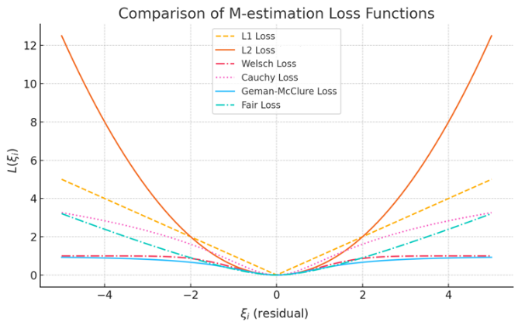

Figure 2 L₁, L₂ Loss vs Comparison of M-estimation

Here, r represents the residual between the predicted and actual label, and c is a tunable parameter controlling sensitivity. These functions increase quickly for small residuals but saturate for large ones, limiting the influence of outliers.This figure illustrates how M-estimators differ from L₁ and L₂ by showing that their loss growth flattens beyond a certain point, while traditional losses increase indefinitely.

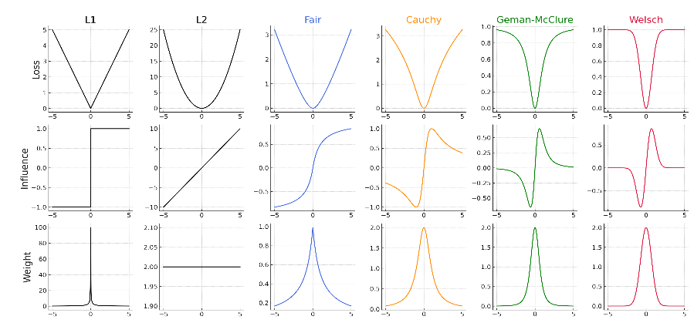

Figure 3 Comparison of Influence and Weight Functions

This figure shows the influence (impact of each residual on the model) and weight (learning importance) functions for each loss. M-estimators reduce both sharply for large residuals, making the model robust to outliers.

This triad of loss, influence, and weight structures is key to enabling robust SVM learning under real-world noisy data. The following section will extend this framework using fuzzy logic to incorporate sample reliability into the learning process.

**4 Proposed Fuzzy M-Estimator SVM**

* 1. **Motivation and Concept**

**4.2 Fuzzy SVMs**

**5 Experimental Results and Discussions**

**6 Conclusions**

**References**

# [1] Xu et al. (2018): “A Survey and Taxonomy of Loss Functions in Machine Learning”

# [2] Zou & Hastie (2005): "Regularization and Variable Selection via the Elastic Net"

# [3] Platt (1998): "Sequential Minimal Optimization: A Fast Algorithm for Training Support Vector Machines"

# [4] Lin et al. (2019): "PSO Optimized 1-D CNN-SVM Architecture for Real-Time Detection and Classification of Diseases"

# [5] Das et al. (2020): "Particle Swarm Optimization-Support Vector Machine Model for Fault Diagnosis of Automotive Gearbox"

# [6] Chen et al. (2021): "Particle Swarm Optimization Algorithm and Its Applications: A Systematic Review"